Lab 3: I Love You Pillow

# Objectives

In this laboratory exercise, you will use the Arduino Lab kit to investigate the use of sensors to touch through a DIY capacitor. Additionally, you will be examining the use of thresholds to output the results to both a buzzer and an external messaging system.

# Introduction

We all know that being without that special person in your life can be difficult, but what if you could send love and affection remotely over the Internet by just hugging a pillow? Now, we can't really send hugs... but what we can send is a sweet emoji through a messaging app, triggered by you giving a pillow a hug. When you hug the I Love You Pillow you will hear the sound of a heartbeat coming from the buzzer inside. Depending on the length of your hug, a different emoji will be sent from a Telegram Bot to whatever chat you choose. Stay in touch with your loved one with this huggable device!

# Libraries needed

* TelegramBot
* WiFiNINA
* ArduinoJson
* CapacitiveSensor

# Lab Procedure

The lab procedure can be found at <https://create.arduino.cc/projecthub/Arduino_Genuino/i-love-you-pillow-with-mkr-wifi-1010-84b6da>. Note: The battery is not needed despite being added in the schematic.

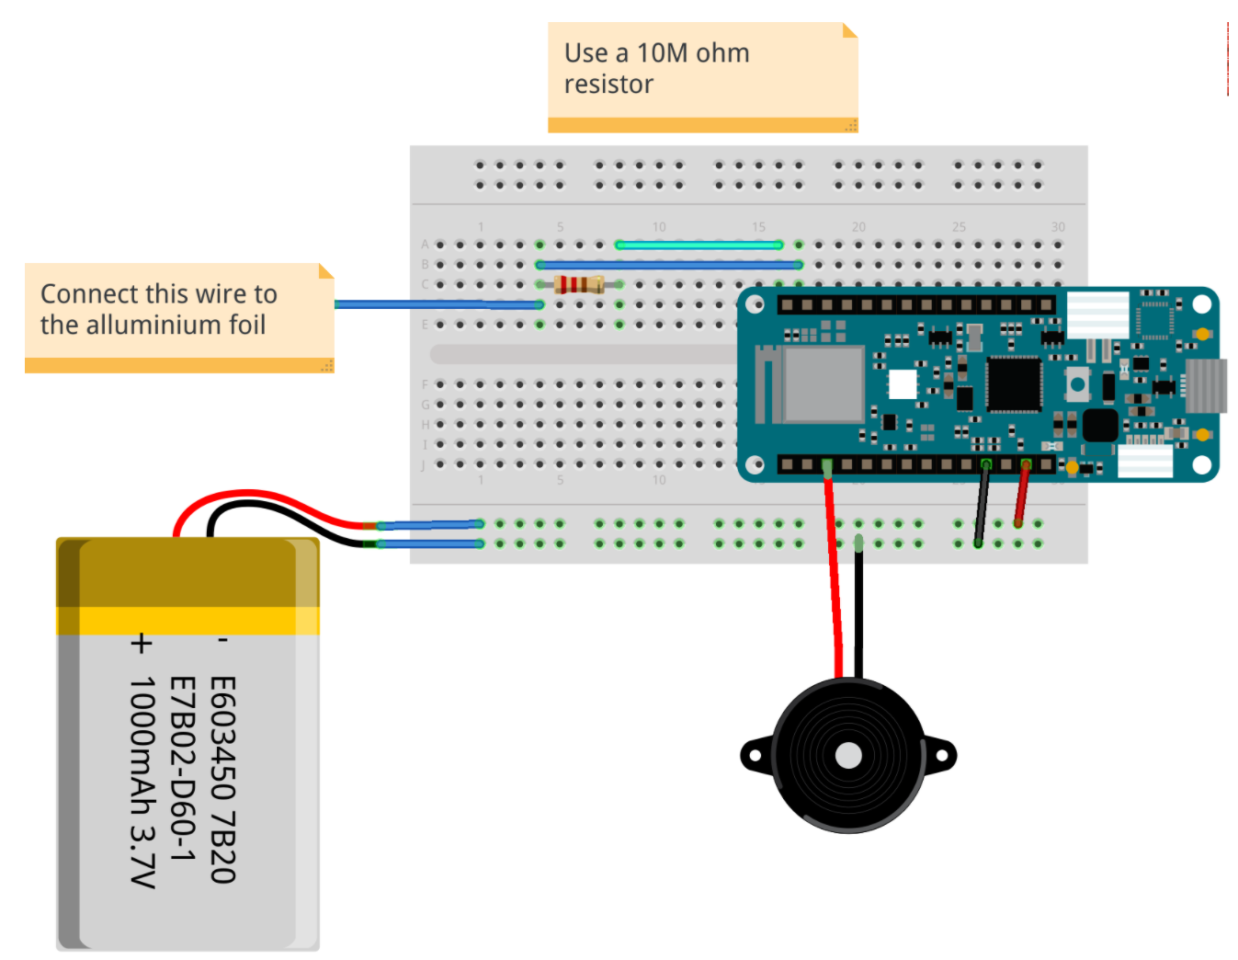

# Lab Tips

### Setting Up Telegram:

* To find BotFather, type “BotFather” in the search bar
* When assigning a name for your bot, you must choose something unique ending in ‘bot’.

### Telegram Testing:

* To find echobot example you must scroll to the bottom of examples
* The process has a delay so make sure you give the Arduino some time to update after your text is sent.

### Capacitor Testing:

* The schematic has a random resistor with the wrong color code. Make sure you use the 10MΩ resistor or values will not register properly.

### NOTE:

When running through this project, the code would not work properly because the library being used for wifi connection was not compatible with my board. If you face this problem, you can try the following:

1. Change all WiFiNINA libraries used in the sketch to WiFi101 and see if problem is resolved.
2. Update the libraries you downloaded to these specific versions:

* Telegrambot version 1.2.1
* ArduinoJson version 5.6.6

Rerun the telegram echo bot from the example and fill in the values it asks for (username, api, wifi…). It should work properly at this point. Additionally, I have adjusted the final sketch for this problem and the sketch can be found in the lab folder if you choose this route.

**LAB 4 REPORT**

Name:

Student No:

**Directions**

Lab report is to be in an organized format, submitted as a single Word file with this sheet as your coversheet. Note: Screen shots of the entire desktop will not be accepted.

Upload the file as a MS Word Docx only. Each group member is to submit their own report and attempt their own models.

**The same measured data may be submitted with each team member that is present; however, each student must turn in a report with that data.**

**Report**

1. Screenshots/images you must include:
   1. Telegram testing: show that the bot is properly echoing sent text messages
   2. Capacitor testing: show the serial monitor as it updates to your touch (under tools tab)
   3. Final circuit image
   4. A short video of your circuit beating when you touch the sensor, and stopping when you remove touch
2. Explain how the capacitive sensor creates change in the signal when someone gets close to the surface. Hint: The aluminum foil acts as only one side a parallel plate capacitor.
3. When building your circuit, assume you only had a small piece of aluminum foil to use for your sensor. Explain how the threshold level will need to be adjusted in comparison to a student with a large sheet.